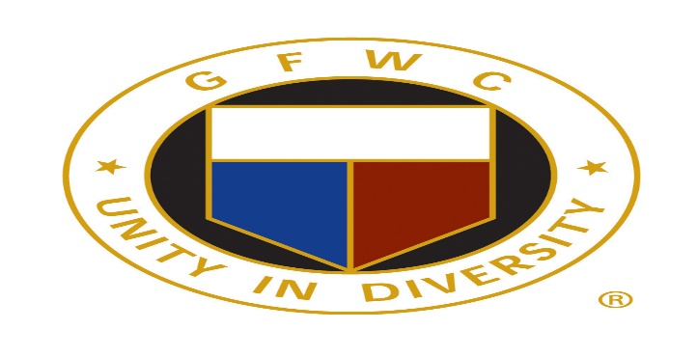
GFWC Woman’s Club of Westminster, Inc.
Press Release
Contact Lynn Wheeler
gfwcwestminster@gmail.com
May 9, 2019
Dean Brewer, Chief Investigator, Carroll County State’s Attorney’s Office was featured speaker at GFWC Woman’s Club of Westminster, Inc.
Dean Brewer, Chief Investigator, Carroll County State’s Attorney’s Office spoke on Recognizing Scams and Frauds, at a meeting of the GFWC Woman’s Club of Westminster, Inc. on Tuesday, April 9. Brewer shared statistics and tips on how to reduce the risk of falling prey to scams via email, phone or walk up solicitation.
Prior to his current position, Brewer was an investigator for the Maryland Attorney General’s Office, Medicaid Fraud Control Unit, where he investigated abuse and neglect of residents in nursing homes, assisted living facilities and group homes for the developmentally disabled.
Brewer has over 42 years of experience in law enforcement. He retired as deputy chief of the Westminster Police Department.
GFWC Woman’s Club of Westminster, Inc. is a nonprofit organization that brings women together in a collective effort to strengthen communities and enhance the lives of others through volunteer service.
Visit our website at www.gfwcmd.org/clubs/western/westminster.womans.html

###

